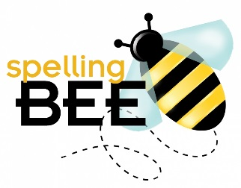
Official Registration for the
2018 Little Cedars School Spelling Bee
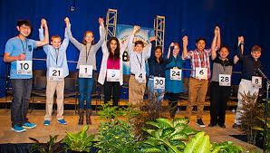
Are you FOURTH, FIFTH, OR SIXTH GRADE super speller who likes a challenge?
Be a contestant in this year’s Little Cedars Spelling Bee! The spelling bee will be held Friday, January 19 at 6:30 PM in
the Little Cedars Multi-Purpose room.
The winner will have the opportunity to advance to the Regional Spelling Bee of
King and Snohomish County
on March 25, 2018 in Seattle.

Turn in the slip at the bottom of this flyer by January 12
to receive a printed study list and be officially registered!
Then go online to SpellingBee.com and follow the Parents and Students link
to create a fee account for access to 2017-2018 study lists.
If you or your parents have any questions, please email Ms. Winter at Julie.winter@sno.wednet.edu, call her at 360-563-2900, or
email Emily Walker at emily@siren-song.com .
+++++++++++++++++++++++++++++++++++++++++++++++++++++++++++++++++++++++++++++++++++++++++++++++++++++++++++++++++++++++++++++++++++++++++++++
Spelling Bee Contestant 2018
Name _________________________________________________________________
Grade ___________ Age __________ Date of Birth ____________________________
Teacher _______________________________________________________________
Printed Parent name________________________ Contact phone: _________________
Contact email: __________________________________________________________

