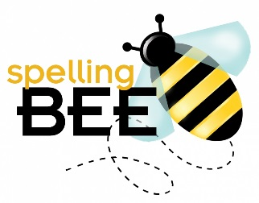
2019 Little Cedars Spelling Bee
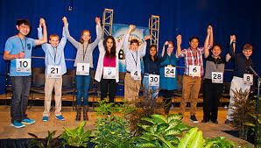
Are you a fourth, fifth, or sixth grade super speller who likes a challenge?
Be a contestant in this year’s Little Cedars Spelling Bee! The spelling bee will be held Thursday, January 24th at 6:30 PM in the multipurpose room. The winner will have the opportunity to advance to the regional spelling bee in Seattle in March.

Turn in the slip at the bottom of this flyer by January 17 to receive a printed study list and links for online study help too.

If you or your parents have any questions, please email Ms. Winter at Julie.winter@sno.wednet.edu or Amanda Whitaker at programs@littlecedarspta.org.
Lets’ Start Spelling!
+++++++++++++++++++++++++++++++++++++++++++++++++++++++++++++++++++++++++++++++++++++++++++++++++++++++++++++++++++++++++++++++++++++++++++++
Spelling Bee Contestant
Name _________________________________
Grade ___________
Teacher _______________________________

